EASO publishes ‘Country Guidance: Nigeria’

* 27TH FEBRUARY 2019

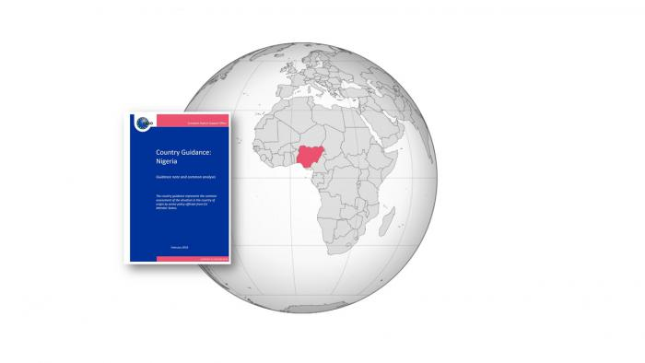

***The country guidance represents the common assessment of the situation in Nigeria by senior policy officials from EU Member States.***

The EASO Management Board endorsed the guidance note on Nigeria in its 31st meeting on 18-19 February 2019. This is the second country guidance published by EASO, after the pilot [‘Country Guidance: Afghanistan’](https://www.easo.europa.eu/sites/default/files/easo-country-guidance-afghanistan-2018.pdf). It represents an important step in consolidating the efforts of Member States to develop common analysis and guidance on main countries of origin, in a process which is coordinated and facilitated by EASO. The guidance reflects the assessment of a network of senior-level policy officials from Member States and associated countries, the EASO Country Guidance Network, and takes into account the input of the European Commission and UNHCR.

The [‘Country Guidance: Nigeria’](https://www.easo.europa.eu/sites/default/files/Country_Guidance_Nigeria_2019.pdf) is a non-binding document. It is intended as a tool for policy-makers and decision-makers in the context of the Common European Asylum System (CEAS) and aims to assist in the examination of applications for international protection, and, ultimately, to foster convergence in the decision practices of Member States.

The guidance provides an in-depth analysis of the situation in Nigeria, focusing on all key elements of qualification for international protection. It looks into the relevant actors of persecution or serious harm; 16 different profiles of applicants, encountered in the caseload, and their potential qualification for refugee status; and the applicability of subsidiary protection under Article 15 of the Qualification Directive. Furthermore, it assesses the ability and willingness of the authorities in Nigeria to provide protection in the meaning of the Qualification Directive; and analyses the availability of internal protection alternative within the country. In its final chapter, the guidance highlights some aspects relevant to the potential exclusion of those who may be found not to be ‘deserving’ of international protection.

The [‘Country Guidance: Nigeria’](https://www.easo.europa.eu/sites/default/files/Country_Guidance_Nigeria_2019.pdf) is based on common up-to-date [country of origin information](https://www.easo.europa.eu/country-origin-information) (COI), produced in accordance with the EASO COI methodology. This information is analysed in line with EU legislation on qualification for international protection ([Directive 2011/95/EU](https://eur-lex.europa.eu/legal-content/EN/TXT/?uri=CELEX:32011L0095)), the case law of the Court of Justice of the European Union and, where appropriate, of the European Court of Human Rights. It takes into account general EASO guidance on the examination of applications for international protection ([EASO practical tools](https://www.easo.europa.eu/practical-tools)).

For further information on EASO’s work on country guidance and to access the ‘Country Guidance: Nigeria’, see <https://www.easo.europa.eu/country-guidance>.